Class 2: Autumn Term 1 2019-20

Welcome Back!
Welcome to Class 2! Everyone at Richard Crosse would like to offer a warm welcome back to both yourself and your child. We hope you have had a lovely summer break and are well and truly rested. This term, your child can look forward to many exciting activities and experiences, to enhance their learning and love of school.

Class 2 | Key Information
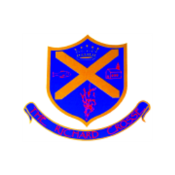  Uniform | School uniform in KS1 is the same as Foundation Stage, other than the children will now be required to wear a tie. Please ensure that your child has their tie on every morning. It would also be helpful if you could ensure that all of your child’s uniform is clearly labelled with their name. This makes it easier to return any lost items.  For further information, please follow the link below.  https://www.richardcrosse.staffs.sch.uk/parents/uniform
Reading Diaries | Please ensure that your child’s reading diary is in school every day, as we aim to try and listen to them read, in school, at least once a week. The children are encouraged to read at least five times a week at home and will need their diary signing by an adult to let us know how they are getting on. The children are responsible for changing their own books, when necessary, but this will be checked on a regular basis. Please note that your child does not have to read a whole book a night, it is acceptable to read just a few pages, especially as the books get trickier. Every time you child reads, they will receive 1 dojo. If they read 5 times in a week, they will be entered into a competition – 5 times reader – with the possibility of winning a book of their choice!
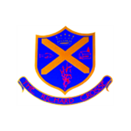  Spellings  Word tins | The children will be given 5 common exception words to learn each week appropriate to their year group. We would love it if you could help your child by writing and reading these words. Spelling tests will take place on a Friday.  Your child will be bringing home a word tin containing 5 sounds that we have been focusing upon during our phonics sessions. These sounds are important when helping the children learn to spell independently, so if you could help them to become confident with them it would be great! This doesn’t have to be done in a formal way, you could write/ say as many words that you can think of with that sound, in a minute and then challenge the children to beat your score.
PE Kit | Your child’s PE kit will need to be in school every day, as we may need to change days at the last minute due to weather etc. Please ensure that all items are clearly labelled with their name. We will send kits home at the end of each half term so that they can be washed.  During the colder months, your child will need a tracksuit top and bottoms.  For further information, please follow the link below.  https://www.richardcrosse.staffs.sch.uk/parents/uniform
Homework  Times Tables | Homework will be sent home every Friday and will need to be handed in on a Wednesday. We will be focusing upon handwriting in Year 1 and joining and comprehension in Year 2.  If your child is in Year 2, they may receive additional work to support their learning.  Year 1: We will be learning our number bonds to 10. We will practise these in school on a Friday.  Year 2: We will be learning 5 times table, which will be tested on a Friday.

Our Curriculum this half term...
English | As part of our English lessons this half term, we will start by writing about our favourite parts of the Summer Holidays. Our next unit will focus upon Stories with familiar settings. We will also have a go at some report and poetry writing.
Maths | The children will have a daily maths session, where we will focus upon our place value knowledge. As we get further into the half term we will also start to look at addition and subtraction, shape and money.  The children will also have an Active Maths session (where they learn a concept through PE) and a Big Maths session (looking at fluency and basic mathematical knowledge) per week.
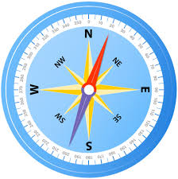  Geography | Our Geography topic this half term will be called ‘Map Makers’ The children will be learning about the 4 compass points, what an aerial photograph is, carrying out some field work tasks and will have a go at making simple maps including basic symbols.
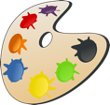  D&T | Our focus will be on food. We will be investigating different types of pizza and having a look at how we could design our own to make it as healthy as possible. The children will then be able to create their own pizzas and bring them home for tea!
Computing | For this session we will focus on E-Safety. Why not support your child by encouraging them to look at the following website and discuss what is on there.  https://www.thinkuknow.co.uk/8_10/
PE | This half term, PE will be taught on a Thursday and a Friday. Our PE topics will be looking at functional movement and the ways in which we move around. We will play lots of different games and learn how to take turns and work within a team.
Religious Education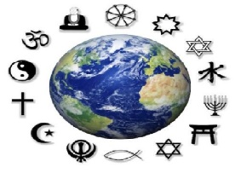 | Who made the world?  We will be investigating where the creation story can be found in the Bible and learning some of the events that led to the creation of the world. We will also take time to think about the ways in which we thank God for his creations.
Science  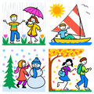 | Seasonal Changes.  We will be learning about the different seasons and how each differs. We will think about how animals and humans are affected, how day length changes and the different weather patterns associated with each season.

