Banana bread recipe
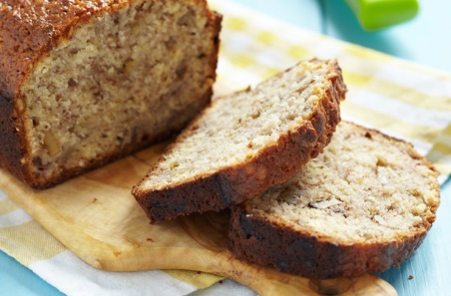

Serves: 8. Prep: 10 Min. Cooking: 35 Min (May Need An Extra 5 Mins)

Ingredients
- 75g (3oz) butter or margarine
- 100g (4oz) soft brown sugar
- 1 egg, beaten
- 2 large ripe bananas
- 225g (8oz) self-raising flour
- 1/2 tsp ground allspice and a pinch of salt
- Handful of dried fruit (dates are good) or chopped walnuts (optional)

Method
- Preheat the oven to 190C, gas 5. Cream the butter and sugar together in a large bowl until fluffy then beat in the egg gradually.
- Add dried fruit. Mash the bananas then stir into the mixture. Fold in the flour, allspice and salt.
- Spoon into a greased and lined loaf tin and bake in the centre of the oven for 35-40 mins, or until a skewer inserted into the centre comes out clean.
- When cooked, leave the banana bread in the tin for a few mins before turning out to cool on a wire rack.
- Serve the banana bread sliced, spread with butter or margarine.

Top tip for making Banana bread
Don't throw away bananas if they start to turn brown – just pop them in the freezer. Use frozen for smoothies, or defrost to make banana bread and cakes.
Taken from www.goodtoknow.co.uk/recipes

